How to add the VI Test framework to your project

The VI Test framework enables you to unit test your VIs quickly and easily. In order to have the framework at your fingertips, you need the framework to be accessible from your project.

Here are the steps to utilize the framework effectively. This procedure assumes you already have your project under SVN.

- Create a folder in your project source folder called ‘Tests’.
- Commit the ‘Tests’ folder.
- Right click the ‘Tests’ folder and select ‘Properties’
- Select the ‘Subversion’ tab and click ‘Properties’ (as shown below)
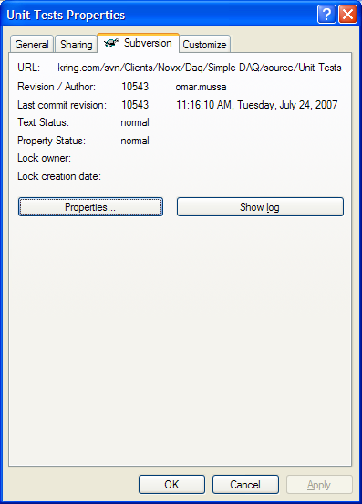
- In the SVN ‘Properties’ dialog click the ‘Add…’ button (as shown below)
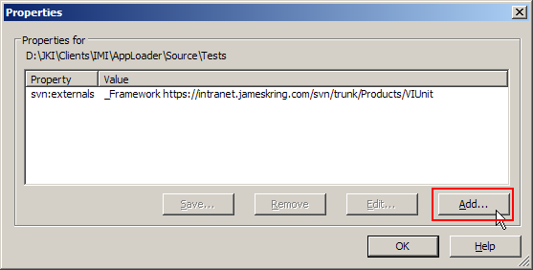
- In the ‘Add Properties’ dialog select ‘svn:externals’ from the ‘Property name’ drop-down list. (as shown below)
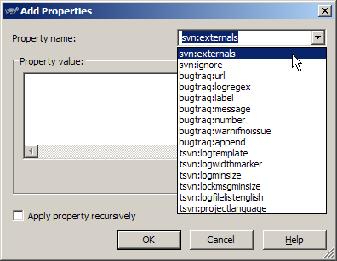
- Enter: ‘_Framework https://intranet.jameskring.com/svn/trunk/Products/VIUnit’ into the ‘Property value’ textbox. (as shown below). DO NOT check the ‘Apply property recursively’ checkbox.
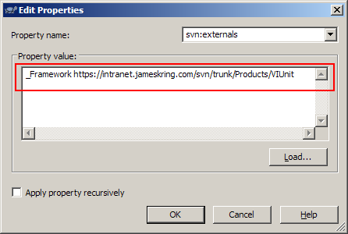
- Press ‘OK’ to close the ‘Add Properties’ dialog.
- Your Properties dialog should look like this (see below). Press ‘OK’.
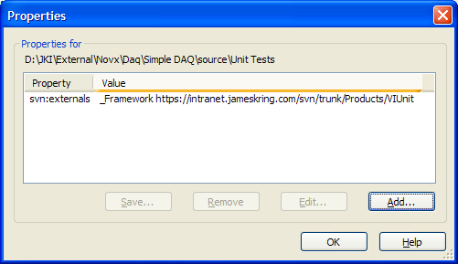
- Commit the ‘Tests’ Folder.
- Do an SVN Update to retrieve the linked data from the product source.
- Create a project file (*.lvproj) in the root of your source folder if you don’t have one already
- Create a virtual folder called ‘Tests’.
- Create a virtual folder called ‘Framework’
- Add the class ‘TestCase.lvclass’ to the ‘Framework’ virtual folder. The TestCase.lvclass should be loctated here:
- Tests\_Framework\Classes\TestCase\TestCase.lvclass
- Add the GUI Test Runner to the project – it is located here:
- Tests\_Framework\User Interfaces\Graphical Test Runner\Graphical Test Runner - Main UI - .vi
- Your project should look like this:
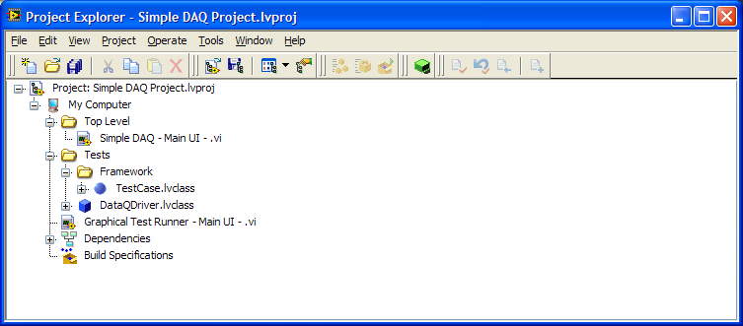
To run tests, open the ‘Graphical Test Runner – Main -.vi’. To create tests, create objects that inherit from TestCase.lvclass and put them in the Tests virtual folder.

